Class works:

Task 1: Design of FIR filters by frequency sampling.

Code:

clc;

close all;

clear all;

Hd=inline('exp(-i*om*(M-1)/2).*(1+abs(om)>(pi/2))','om','M');

M=9;

ok=[0:(M-1)]/M*2*pi;

Hk=Hd(mod(ok+pi,2*pi)-pi,M); %trick: [-pi,pi] specification of H(\omega)

h=ifft(Hk);

h=fir2(M-1, [0 0.5 .5 1],[1 1 2 2],boxcar(M)); %%high pass like magnitude

om=linspace(-pi,pi,201);

clf,

pl=230;

subplot(pl+1),plot(om,abs(Hd(om,M)))

hold on,

stem(ok(ok>=0),abs(Hk(ok>=0)),'filled'),

xlabel('\omega');

ylabel('|H_d(\omega)|');

subplot(pl+2),stem(0:(M-1),h,'filled'),title(sprintf('M=%d',M))

xlabel('n');

ylabel('h[n]');

axis([0 M-1 -.5 1.5])

H=freqz(h,1,om);

subplot(pl+3),plot(om,abs(H),'-',om,abs(Hd(om,M)),'--',ok,abs(Hk),'o')

xlabel('\omega');ylabel('|H(omega)|'),

Figure 5.1 : Design of FIR filter by frequency sampling

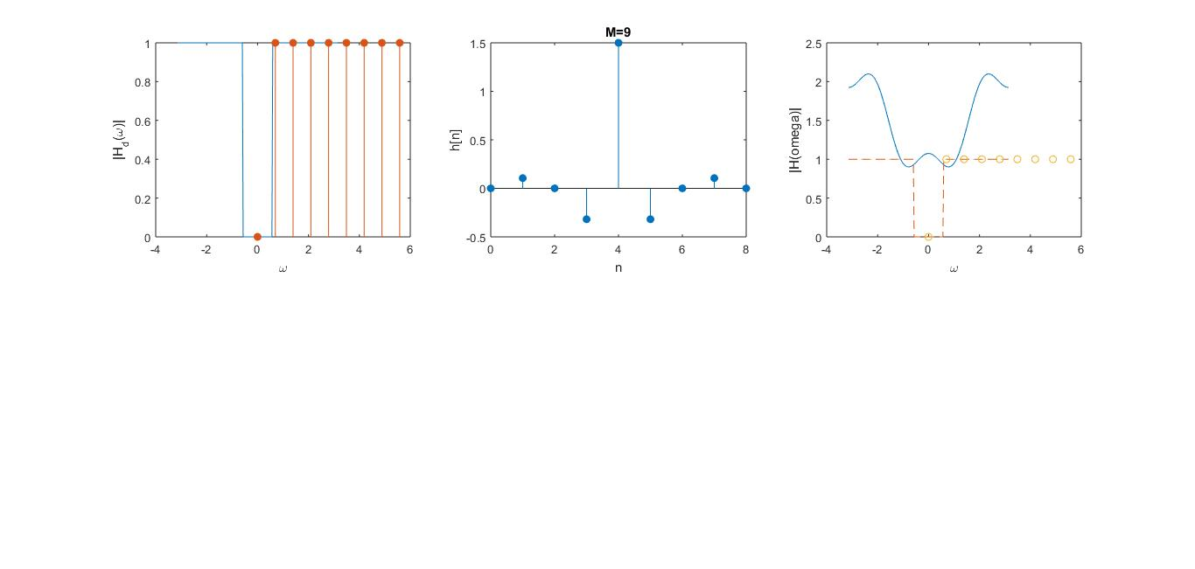

Task 2: Design of linear phase FIR filters using window

Code:

clc;

clear all;

close all;

M=15;

n=[0:(M-1)];

om=linspace(-pi,pi,201); %for displaying freq response

oc=pi/4; %cuttoff freq

%desired response:

hd=inline('oc/pi*sinc(oc/pi*(n-(M-1)/2))','n','oc','M');

Hd=inline('1*abs(om)<oc','om','oc');

hn_hann=hd(n,oc,M).*hann(M)'; %hanning window applied to ideal impulse

hn_rectwin=hd(n,oc,M).*rectwin(M)'; %rectwin window applied to ideal impulse response

hn_blackman=hd(n,oc,M).*blackman(M)'; %blackman window applied to ideal impulse response

hn_hamming=hd(n,oc,M).*hamming(M)'; %hamming window applied to ideal impulse response

hn_kaiser=hd(n,oc,M).*kaiser(M)'; %kaiser window applied to ideal impulse response

hn_triang=hd(n,oc,M).*triang(M)'; %triang window applied to ideal impulse response

figure(1),subplot(211)

stem(n,hn_hann,'filled'),

axis([0 M-1 -.1 .3]),xlabel 'n', ylabel 'h[n]'

title(sprintf('Hanning Lowpass, M=%d',M))

subplot(212)

H=freqz(hn_hann,1,om);

plot(om,20*log10(abs(H)),'-',om,20*log10(max(Hd(om,oc),eps)),'--')

xlabel('\omega');

ylabel('|H(\omega)|(dB)');

title('Magnitude response (Hanning)');

figure(2),subplot(211)

stem(n,hn_hamming,'filled'),

axis([0 M-1 -.1 .3]),xlabel('n'), ylabel('h[n]')

title(sprintf('Hamming Lowpass, M=%d',M))

subplot(212)

H=freqz(hn_hamming,1,om);

plot(om,20*log10(abs(H)),'-',om,20*log10(max(Hd(om,oc),eps)),'--')

xlabel('\omega');

ylabel('|H(\omega)|(dB)');

title('Magnitude response (Hamming)');

figure(3),subplot(211)

stem(n,hn_rectwin,'filled'),

axis([0 M-1 -.1 .3]),xlabel('n'), ylabel('h[n]')

title(sprintf('Rect. window Lowpass, M=%d',M))

subplot(212)

H=freqz(hn_rectwin,1,om);

plot(om,20*log10(abs(H)),'-',om,20*log10(max(Hd(om,oc),eps)),'--')

xlabel('\omega');

ylabel('|H(\omega)|(dB)');

title('Magnitude response (rect. window)');

figure(4),subplot(211)

stem(n,hn_blackman,'filled'),

axis([0 M-1 -.1 .3]),xlabel('n'), ylabel('h[n]')

title(sprintf('Blackman window Lowpass, M=%d',M))

subplot(212)

H=freqz(hn_blackman,1,om);

plot(om,20*log10(abs(H)),'-',om,20*log10(max(Hd(om,oc),eps)),'--')

xlabel('\omega');

ylabel('|H(\omega)|(dB)');

title('Magnitude response (Blackman window)');

figure(5),subplot(211)

stem(n,hn_kaiser,'filled'),

axis([0 M-1 -.1 .3]),xlabel 'n', ylabel 'h[n]'

title(sprintf('kaiser window Lowpass, M=%d',M))

subplot(212)

H=freqz(hn_kaiser,1,om);

plot(om,20*log10(abs(H)),'-',om,20*log10(max(Hd(om,oc),eps)),'--')

xlabel('\omega');

ylabel('|H(\omega)|(dB)');

title('Magnitude response (kaiser window)');

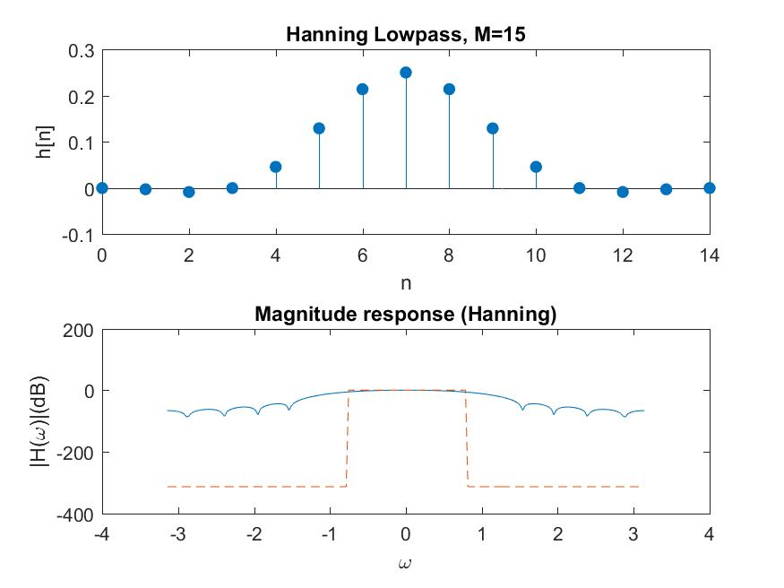

Figure 5.2: Design and magnitude response of hanning window.

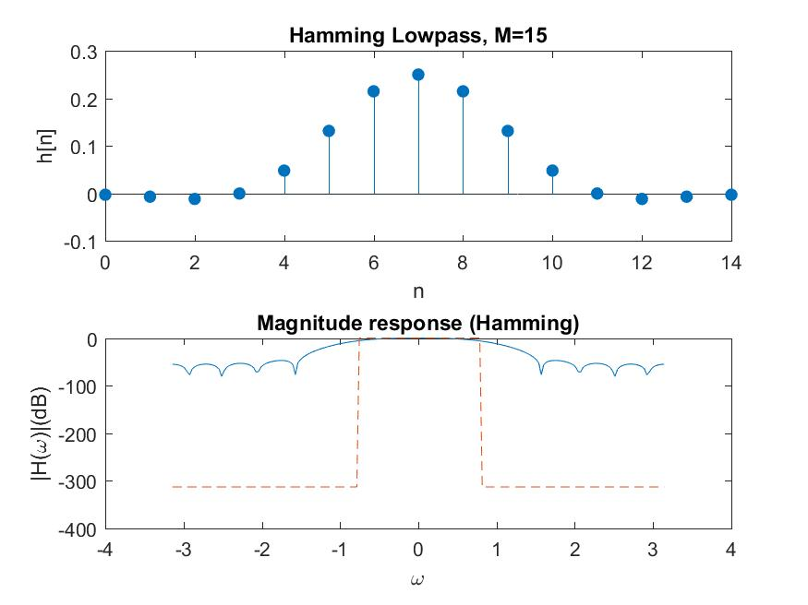

Figure 5.3: Design and magnitude response of hamming window.

Home Work:

Question: A high pass filter has the desired response as given below:

Hd (ejw)={ 0 , for $0≤w≤⌅/2$; e-jw3 for $⌅/2≤w≤⌅$

Determine the filter coefficients h(n) for M=7 using type I frequency sampling technique and also plot it.

Code:

clc;

close all;

clear all;

Hd=inline('exp(-i*om*3*(M-1)/2).*(1+abs(om)>(pi/2))','om','M');

M=7;

ok=[0:(M-1)]/M*2*pi;

Hk=Hd(mod(ok+pi,2*pi)-pi,M); %trick: [-pi,pi] specification of H(\omega)

h=ifft(Hk);

h=fir2(M-1, [0 0.5 .5 1],[1 1 2 2],boxcar(M)); %%high pass like magnitude

om=linspace(-pi,pi,201);

clf,

pl=230;

subplot(pl+1),plot(om,abs(Hd(om,M)))

hold on,

stem(ok(ok>=0),abs(Hk(ok>=0)),'filled'),

xlabel('\omega');

ylabel('|H_d(\omega)|');

subplot(pl+2),stem(0:(M-1),h,'filled'),title(sprintf('M=%d',M))

xlabel('n');

ylabel('h[n]');

axis([0 M-1 -.5 1.5])

H=freqz(h,1,om);

subplot(pl+3),plot(om,abs(H),'-',om,abs(Hd(om,M)),'--',ok,abs(Hk),'o')

xlabel('\omega');ylabel('|H(omega)|'),

Figure 5.8 : Design of given FIR filter by frequency sampling

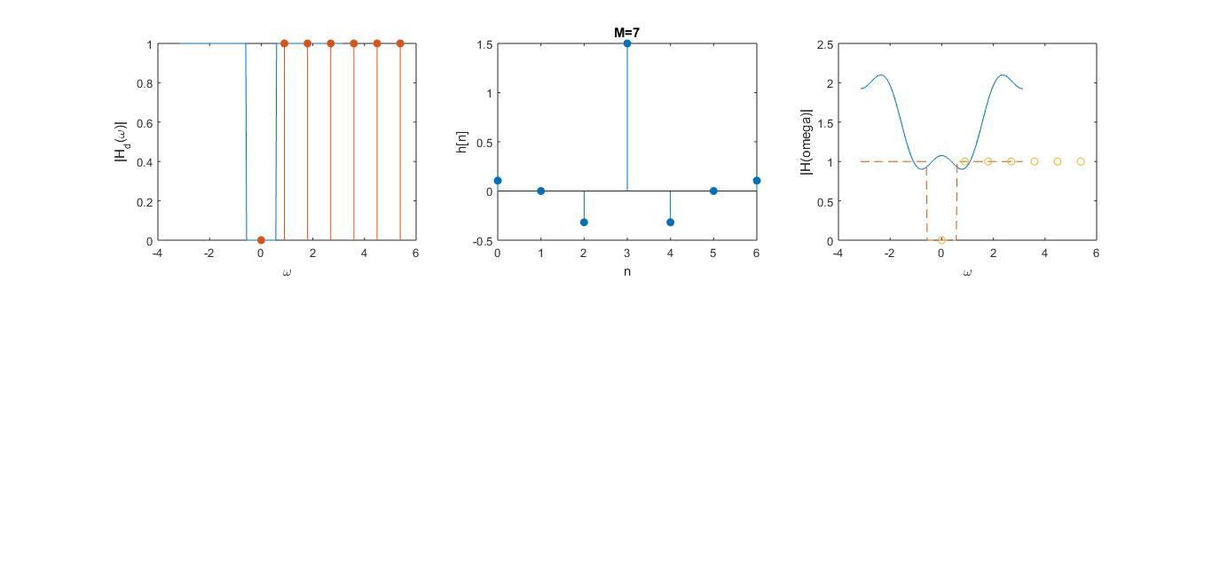

Figure 5.7: Design and magnitude response of triangular window.

Figure 5.6: Design and magnitude response of kaiser window.

Figure 5.5: Design and magnitude response of blackman window.

Figure 5.4: Design and magnitude response of rectangular window.

